37 Editors - File browser by tools
File Browser 2
Back to Previous 3
Header tools 3
Editor Type menu 3
Folder Navigation 3
Previous Folder 3
Next Folder 3
Parent File 4
Refresh List 4
Create new Directory 4
Recursion 4
None 4
One Level, Two Levels, Three Levels 4
Display mode for File List 4
Short List 4
Long List 4
Thumbnails 5
Display Size 5
Sort Method 5
Alphabetically 5
By Extension Type 5
By Modification Time 5
By Size 5
Show hidden Dot Files 5
Filtering 5
Enable Filtering of Files 6
Show Folders 6
Show Blend files 6
Show Blend1, Blend2, Blend3, etc. files 6
Show Image files 6
Show Movie Files 6
Show Script files 6
Show Font files 6
Show Sound files 6
Show Text files 6
Filter by string 6
Tool Shelf 7
System Panel 7
System Bookmarks 7
Bookmarks 7
Recent 7
Import Export Settings 8
Load UI 8
Trusted Source 8
File dialog 8
Path edit box 8
Open / Save Button 8
File edit box 8
+ and - Buttons behind File Edit box 8
Cancel Button 9
File Dialog navigation 9

File Browser
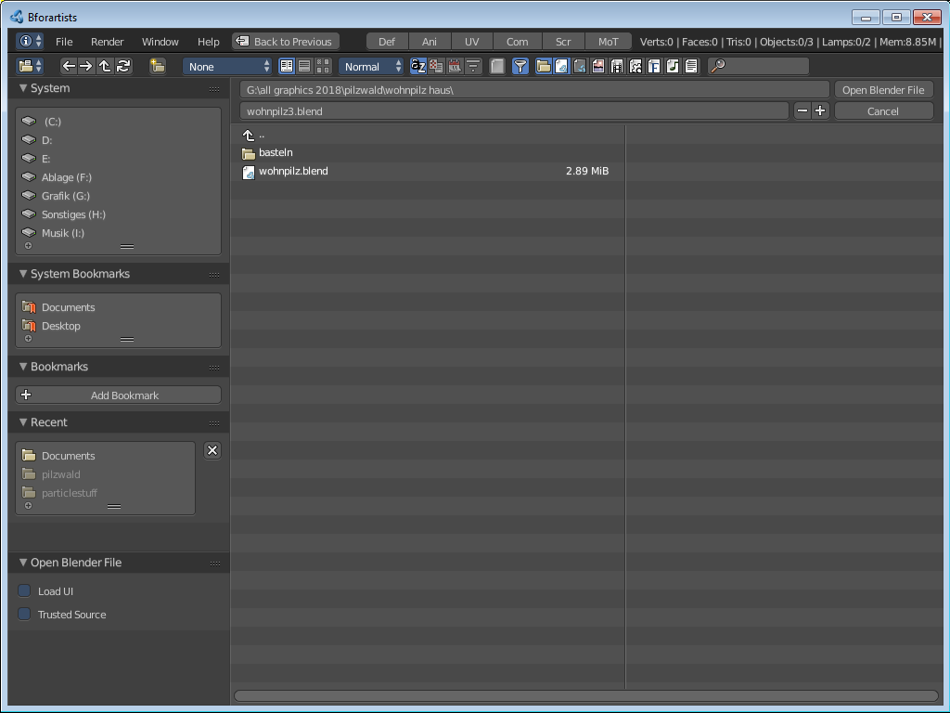
The file browser is a explorer dialog that allows you to browse for locations and files, and allows you to load and save them.
The file browser has multiple uses. While its often used for save/load, it can be kept open for other uses too.
Use cases include:
- Opening and Saving Blend files.
- Import/Export other file formats.
- Picking new locations for existing file-paths (images, video’s, fonts... etc).
- Browsing inside other .blend files, when using Append and Link.
You can also keep the file selector open, as with any other window type. In this case the buttons to load files is removed. The main purpose of this is to be able to drag media files.
- Images into the Video Sequence Editor (to set background or apply as material textures).
- Media files into the Video Sequence Editor.

Back to Previous
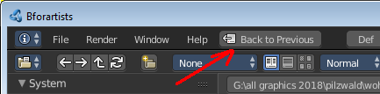
Once you open the file browser you will see a "Back to Previous" Button in the header of the Info Editor. This allows you to leave the File Browser when you decide not to load or save. The same can of course be done with the Cancel button.

Header tools

There are several tools in the header to find. The range goes from navigation elements across filters up to display options. Some defaults differs, dependant of what file format you try to load or to save.

Editor Type menu

Allows you to change the editor type from File Browser to another editor type.

Note
This menu is required when you build layouts. You can for example incorporate the file browser into a layout as a drag n drop location for your movies.

In a callable file browser it's a bit disturbing, and should be hidden. But there is unfortunately no way to hide it by default since when you call the file browser then you create the editor type from scratch, with this menu showing.This means we have to live with this menu here.

Folder Navigation

Previous Folder
Navigates to the previous folder location

Next Folder
Navigates to the next folder location. This just works when you had Previous folder clicked before.

Parent File
Moves one upwards in the explorer hierarchy

Refresh List
Refreshes the file list. This is useful when you did some modifications at the folder content outside of the file browser.

Create new Directory
Creates a new folder inside of the currently selected directory.

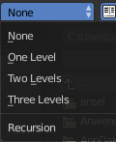
Recursion
Recursion is a dropdown menu where you can adjust how deep the explorer should dig. Normally it just lists the content of the currently selected directory. But it is also possible to list the content of the folders three levels lower.
The recursion direction is always downwards. Default is None.

None
Just the matching content of the current directory is showing.

One Level, Two Levels, Three Levels
The matching content of the current directory is showing, plus the content of possible subfolders, defined by how deep the search should go.

Display mode for File List
There are three methods to display the content of the folders.

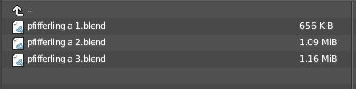
Short List
Displays the content of the file browser as a short list. Just File name and size gets displayed.

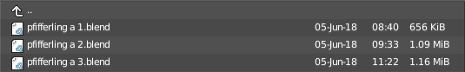
Long List
Displays the content of the file browser as a list. Besides Filename and Size also the create date gets displayed.

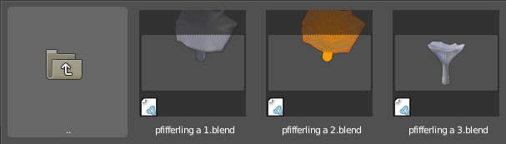
Thumbnails
Displays the content of the file browser as thumbnails. This is especially for images of use.

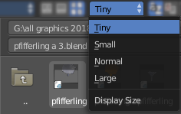
Display Size
Here you can adjust how big the directory content gets displayed.

Sort Method
Here you can adjust how the directory list gets sorted.

Alphabetically
Sorts the content by its name.

By Extension Type
Sorts the content by the extension type.

By Modification Time
Sorts the content by date.

By Size
Sorts the content by size.

Show hidden Dot Files
This is a Unix feature. Unix systems like Linux or Mac hides files from file browsers and explorers by having a dot before the file. A good example is the .htaccess file at servers. Show hidden Dot Files makes such files visible to the file browser.

Filtering
You can filter the content of the file browser in various ways. The defaults differs, dependant of what you want to load or to save.

Enable Filtering of Files
This is the button that enables or disables filtering at all.

Show Folders
Display folders.

Show Blend files
Display Blend files.

Show Blend1, Blend2, Blend3, etc. files
Display blender backup scenes. Blender creates sometimes backups with the file ending with an increasing number at the end. blend1 for example.

Show Image files
Display image files.

Show Movie Files
Display movie files.

Show Script files
Display script files

Show Font files
Display font files.

Show Sound files
Display sound files.

Show Text files
Display text files.

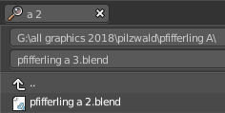
Filter by string
Here you can filter the results in the file browser by a string.

Tool Shelf

The Tool Shelf provides you with some panels for quick access to files and bookmarks.

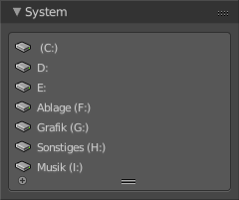
System Panel
Lists your drives.

System Bookmarks
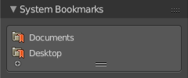
Lists some system libraries.

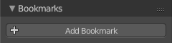
Bookmarks
Here you can add your own bookmarks.
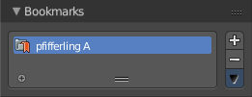

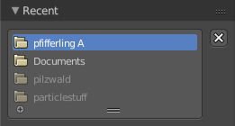
Recent
A list of the recent accessed folders.
Greyed out folders are not longer existing directories. There is unfortunately no way to remove them from within Bforartists. You would need to do this manually in the History text files in the settings folder.
Under Windows this is the bookmarks.txt file in the Appdata folder.

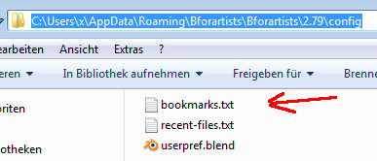

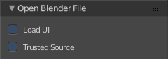
Import Export Settings
At the lower half of the Tool Shelf you will find the special Import or Export settings for the current file format. For a Blend file you will just see two entries. For file formats like FBX you wil find plenty of settings.
As an example, and to explain the two settings for loading a blend file:

Load UI
Bforartists comes with the feature *Load UI* unticked. This means the Bforartists UI will not change when you load a scene. Here you can temporary enable to load the scene with the layout and UI arrangement in which the scene was saved.

Trusted Source
With Load UI you can also load script files, which can execute. This is a potential security risk when the file comes from an unknown source.

File dialog

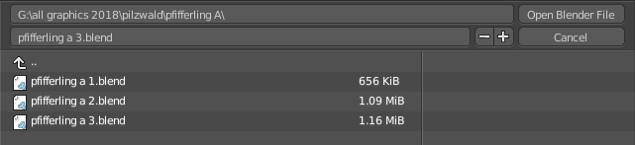
The file dialog is the actual place where your files and directories gets listed.

Path edit box
Here you can see and edit the full path to the file. And here you can set or modify it manually too. But usually you will use the navigation elements in the tool shelf. Or navigate by clicking at the folders and items in the list.

Open / Save Button
Execute loading or saving. For file loading, you can also double click at the file in the list to open it.

File edit box
Here you can read the file name. When you save a file, then this is the place to insert your needed file name.

+ and - Buttons behind File Edit box
This feature is of interest when you want to save a file with increasing number. The + button adds a increasing number at the end of the file name. The - button decreases this value. This means when you have a file with no number at the end, like cube, then the name changes to cube1. When the name is cube1, and you press the + button, then the name changes to cube2. When the file name is cube2, and you press the + button, then the file name changes to cube3. And so on.
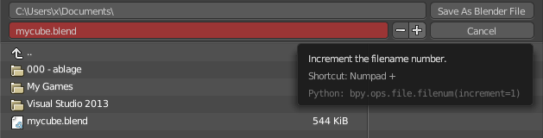
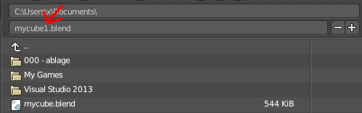

The red color indicates that a file with this name already exists.

Cancel Button
Cancel the load or save action completely. The file dialog will close.

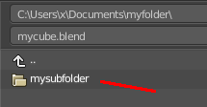
File Dialog navigation
Usually you move one hierarchy downwards by simply clicking at the folder in the list that you want to explore.

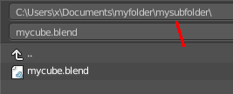
So when i click at "mysubfolder" here, then we will enter this folder. And its content gets displayed. As you can see, the path has changed. We are now in the subfolder directory.
A double click at the mycube.blend file will open the file then.
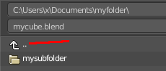
There is also a way to navigate upwards. It's the arrow button in the list. A click at it, and we are back at the parent directory.

